**What is DevOps?**

* **DevOps** is a collaboration between Development and IT Operations to make software production and Deployment in an automated & repeatable way. DevOps helps increase the organization’s speed to deliver software applications and services. The full form of ‘DevOps’ is a combination of ‘Development’ and ‘Operations.’
* It allows organizations to serve their customers better and compete more strongly in the market. In simple words, DevOps can be defined as an alignment of development and IT operations with better communication and collaboration.

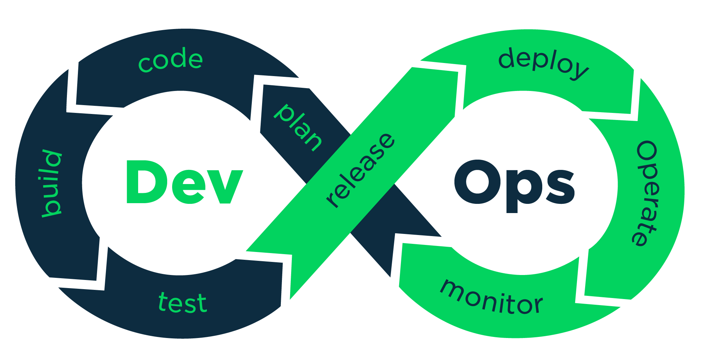

1. What is Automation, Scaling, Infrastructure

**AUTOMATION:**

Automating infrastructure set up and configurations, and software deployment is the key highlight of DevOps practice. DevOps practice id is dependent on automation to make deliveries over a few hours and make frequent deliveries across platforms.

**SCALING:**

Scaling in DevOps is characterized as an automation-driven environment where developers or companies can adopt DevOps culture and choose the right technologies to scale their business growth.

**INFRASTRUCTURE:**

DevOps infrastructure or Infrastructure Automation under DevOps refers to a concept that revolves around the idea of managing infrastructure with the help of code. This is done with the help of certain tools or programs which can help to carry out the tasks automatically

1. Why DevOps is Important

### **Shorter development cycles that encourage innovation**

### **More collaboration, better communication**

### **Reduced deployment failures and faster time to recover**

### **Efficiency: Improved resource management**

### 